

University OF Layyah
(Department OF Information & Tecnology)

API Test Cases

Submitted To:

Sir Faisal Hafeez

Subject:

Software Testing & Quality Assurance

Test Case ID | TC_API_01
Test Case Title | Verify Wikipedia search API returns results for valid keyword
API Type | GET
API End Point | https://en.wikipedia.org/w/api.php
Request Parameters | action=query  list=search  srsearch=Software testing  format=json
Full Request URL | https://en.wikipedia.org/w/api.php?action=query&list=search&srsearch=Software testing&format=json
Expected Result | API should return HTTP 200 status code  Search results related to "Software testing" should appear in response
Actual Result | Search results returned successfully with related articles
Status | Pass
Remarks | Valid keyword search working correctly

Screenshot:

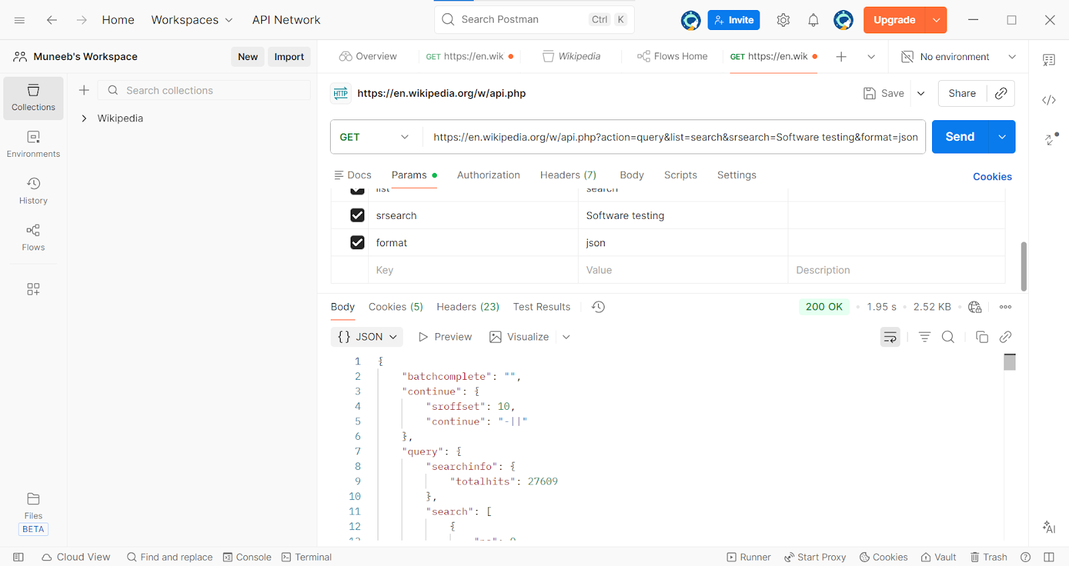

Test Case ID | TC_API_02
Test Case Title | Invalid value passed in format parameter
API Type | GET
API End Point | https://en.wikipedia.org/w/api.php
Request Parameters | action=query  list=search  srsearch=Software testing  format=json
Full Request URL | https://en.wikipedia.org/w/api.php?action=query&list=search&srsearch=Software%20testing&format=json
Expected Result | API should reject invalid format value and return meaningful error message
Actual Result | API returned error response with code "badvalue" due to invalid format parameter.
Status | Pass
Remarks | Valid keyword search working correctly

Screenshot:

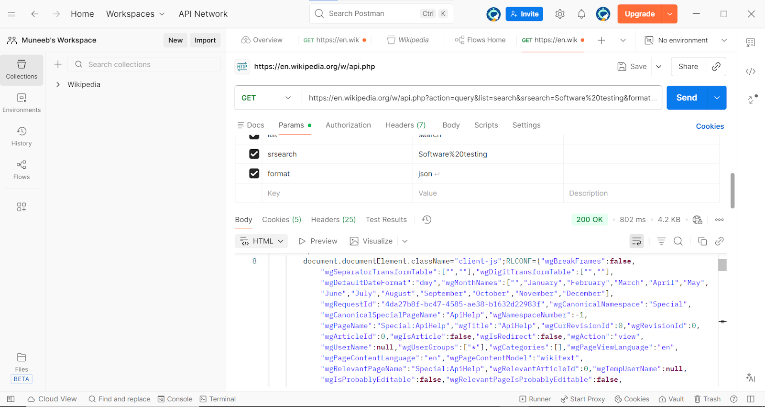

Test Case ID | TC_API_03
Test Case Title | Verify API behavior when search parameter is empty
API Type | GET
API End Point | https://en.wikipedia.org/w/api.php
Request Parameters | action=query  list=search  srsearch=  format=json
Full Request URL | https://en.wikipedia.org/w/api.php?action=query&list=search&srsearch=&format=json
Expected Result | API should return an error or empty result indicating missing search keyword
Actual Result | API returned error message indicating that the search parameter value is required
Status | Pass
Remarks | Negative test case validated; API correctly handled empty search parameter

Screenshot:

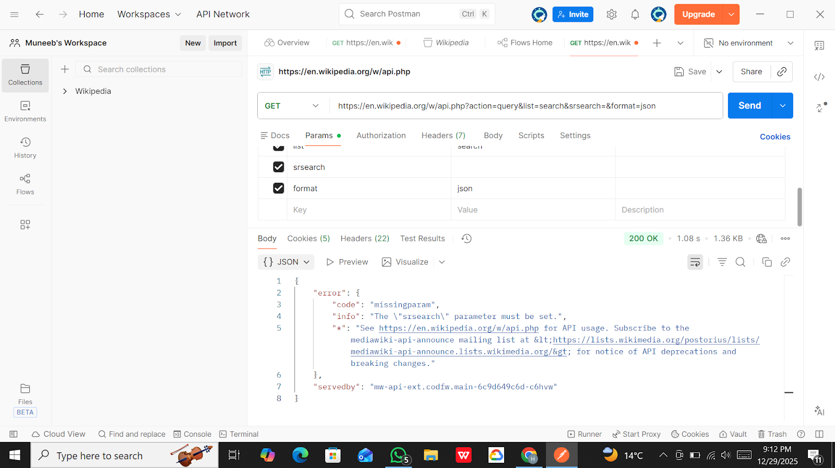

Test Case ID | TC_API_4
Test Case Title | Verify API response when requesting large number of search results using srlimit parameter
API Type | GET
API End Point | https://en.wikipedia.org/w/api.php
Request Parameters | action=query  list=search  srsearch=Software testing  srlimit=20  format=json
Full Request URL | https://en.wikipedia.org/w/api.php?action=query&list=search&srsearch=Software+testing&srlimit=20&format=json
Expected Result | API should return multiple search results (up to the limit specified) without errors
Actual Result | API returned multiple search results within the defined limit and response was successful
Status | Pass
Remarks | API successfully handled large result request using srlimit parameter

Screenshot:

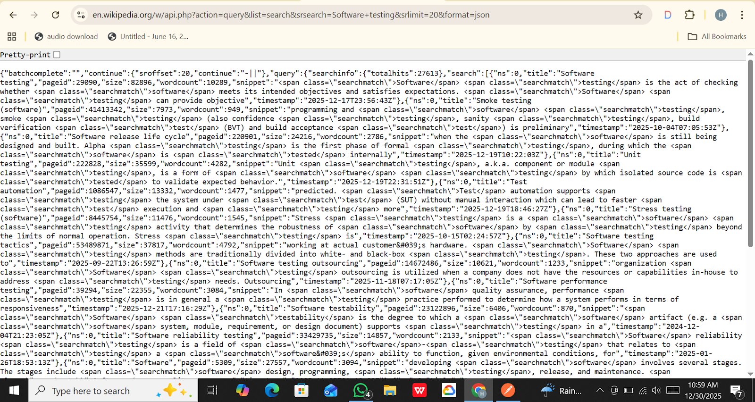

Test Case ID | TC_WIKI_API_5
Test Case Title | Verify that Wikipedia Search API returns results based on specified language
API Type | GET
API End Point | https://en.wikipedia.org/w/api.php
Request Parameters | action=query  list=search  srsearch=Software testing  format=json  uselang=ur
Full Request URL | https://en.wikipedia.org/w/api.php?action=query&list=search&srsearch=Software testing&format=json&uselang=ur
Expected Result | API should return search results with content affected by the specified language parameter (Urdu).
Actual Result | API returned valid search results and processed the language parameter successfully.
Status | Pass
Remarks | Language-specific parameter handled correctly; API response returned without error.

Screenshot:

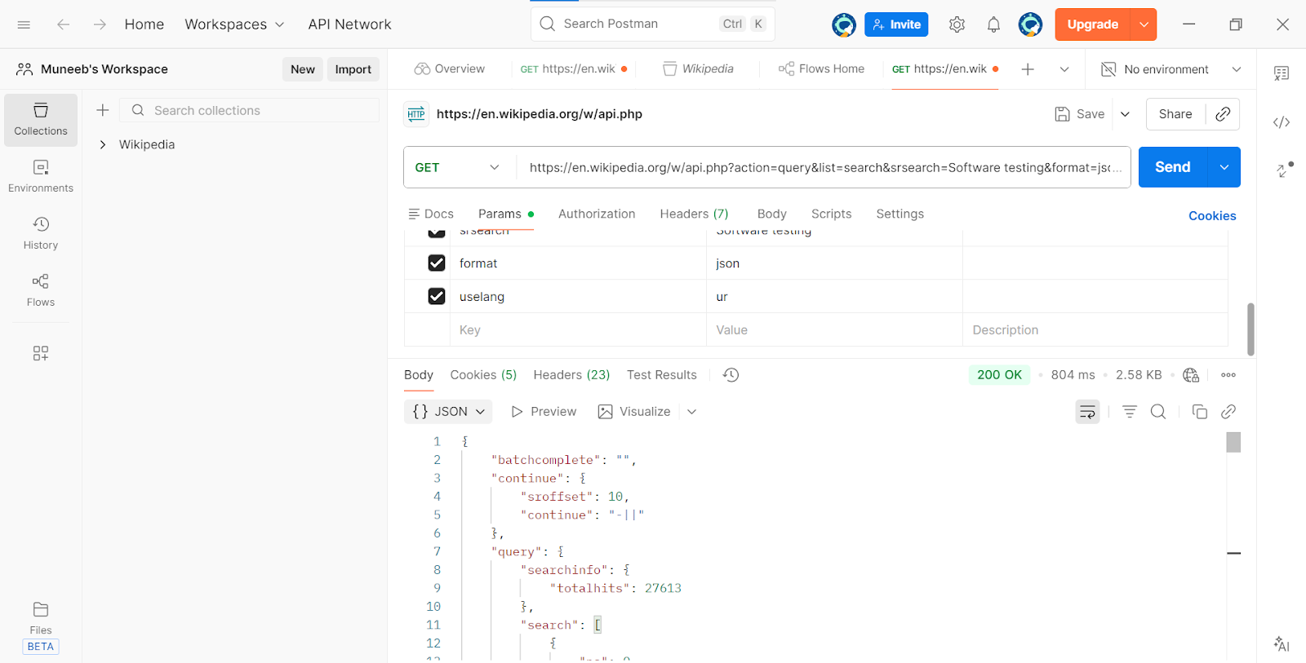

Test Case ID | TC_API_6
Test Case Title | Verify pagination using continue (sroffset) parameter in Wikipedia Search API
API Type | GET
API End Point | https://en.wikipedia.org/w/api.php
Request Parameters | action=query  list=search  srsearch=software testing  format=json  srlimit=10
Full Request URL | https://en.wikipedia.org/w/api.php?action=query&list=search&srsearch=software+testing&format=json&srlimit=10  https://en.wikipedia.org/w/api.php?action=query&list=search&srsearch=software+testing&format=json&srlimit=10&sroffset=10
Expected Result | API should return the next page of search results when sroffset parameter is used
Actual Result | API returned the next set of search results successfully using sroffset parameter
Status | Pass
Remarks | Pagination working correctly; API supports continue parameter for large result sets

Screenshot:
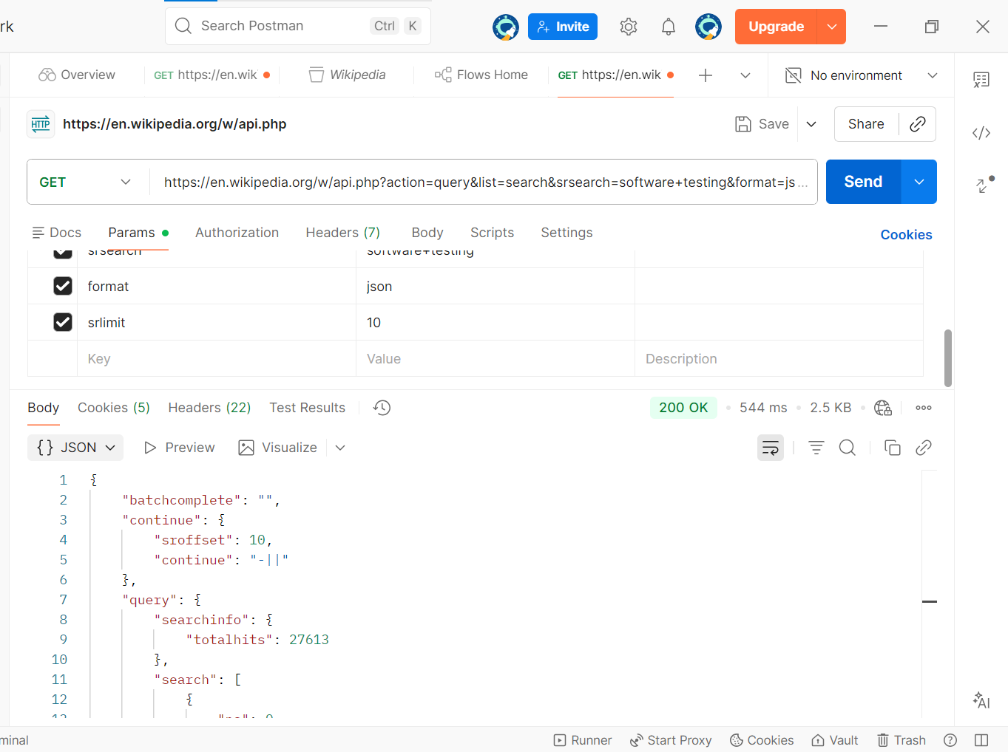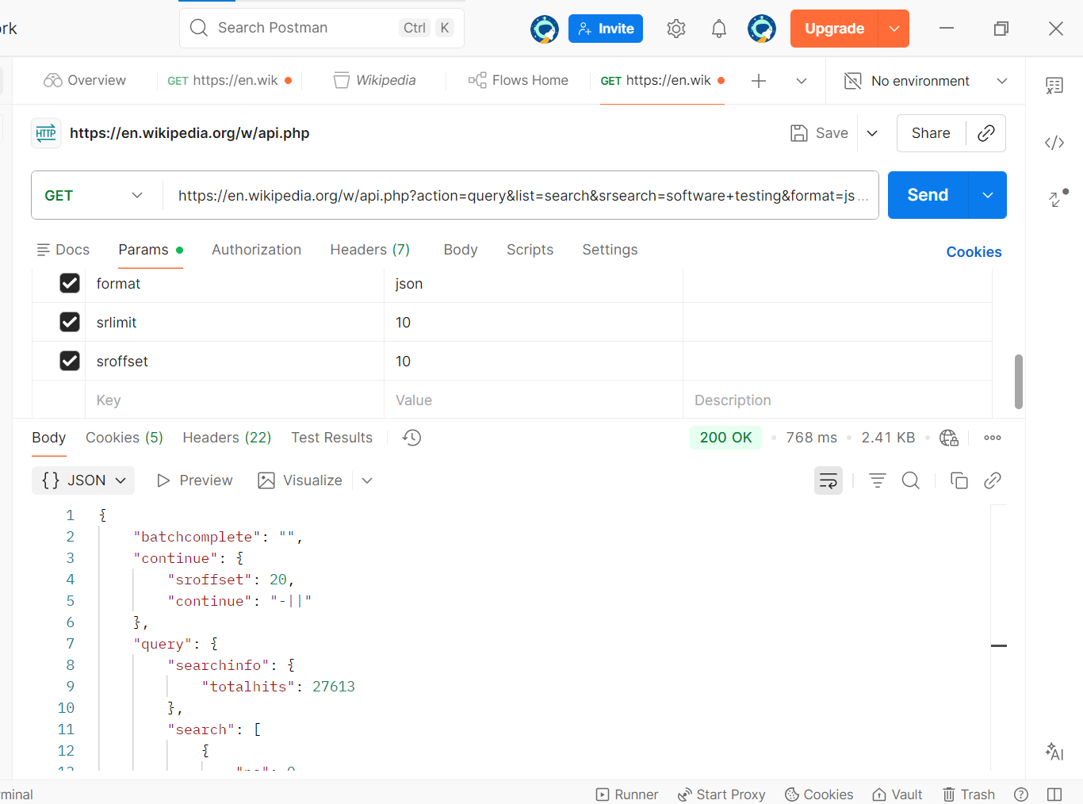

Test Case ID | TC_API_7
Test Case Title | Verify that Wikipedia API responds correctly to unauthorized or invalid parameter requests
API Type | GET
API End Point | https://en.wikipedia.org/w/api.php
Request Parameters | action = query  list = search  srsearch = software testing  srlimit = 10  format = invalidformat123
Full Request URL | https://en.wikipedia.org/w/api.php?action=query&list=search&srsearch=software+testing&srlimit=10&format=invalidformat123
Expected Result | API returns an error object  Error message mentions unrecognized or invalid  parameter  No search results are returned
Actual Result | Error returned: "Unrecognized value for parameter 'format': invalidformat123"  No search results provided
Status | Pass
Remarks | API correctly handles invalid parameter requests  Security / input validation verified

Screenshot:

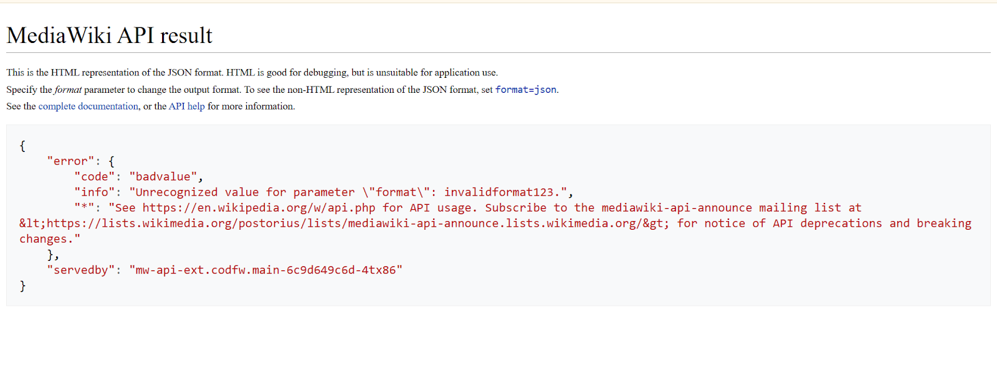

Test Case ID | TC_API_08
Test Case Title | Verify Wikipedia API returns correct content for a specific page
API Type | GET
API End Point | https://en.wikipedia.org/w/api.php
Request Parameters | action=query  format=json  prop=revisions  titles=Software_testing  rvprop=content
Full Request URL | https://en.wikipedia.org/w/api.php?action=query&format=json&prop=revisions&titles=Software_testing&rvprop=content
Expected Result | API should return page content of "Software_testing" with revisions included
Actual Result | API returned JSON with page ID, title, and content under "revisions"
Status | Pass
Remarks | Page content fetched correctly; API handles page content requests without errors

Screenshot:

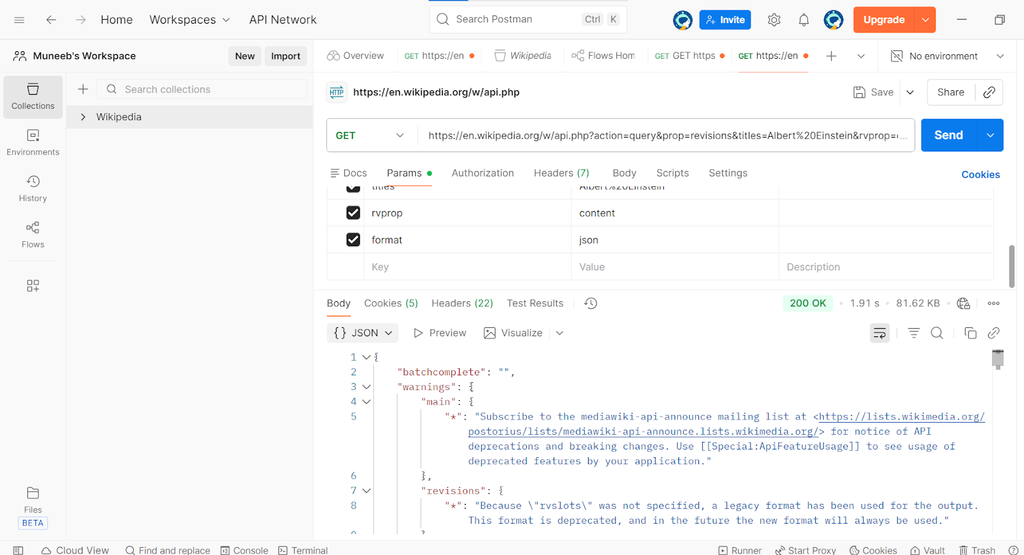

Test Case ID | TC_API_09
Test Case Title | Verify Wikipedia API response for fetching page revisions with rvslots=main parameter
API Type | GET
API End Point | /w/api.php
Request Parameters | action=query  format=json  prop=revisions  titles=Albert Einstein  rvslots=main  rvlimit=1
Full Request URL | https://en.wikipedia.org/w/api.php?action=query&format=json&prop=revisions&titles=Albert%20Einstein&rvslots=main&rvlimit=1
Expected Result | API returns JSON containing "query" -> "pages" with page ID for Albert Einstein.  "revisions" array should contain latest revision content.  No errors, only possible warnings about deprecated features.
Actual Result
Status | Pass
Remarks | Ensure rvslots=main is added to avoid legacy format warning.  This test focuses on fetching revisions, not search results.

Screenshot:

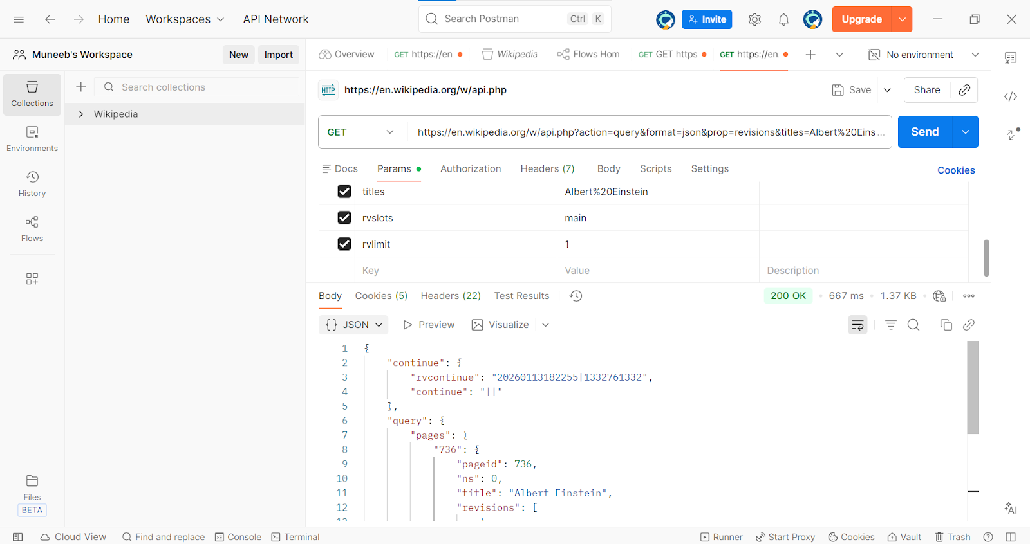

Test Case ID | TC_API_10
Test Case Title | Verify Wikipedia API retrieves page categories
API Type | GET
API End Point | /w/api.php
Request Parameters | action=query  format=json  prop=categories  pageids=736  cllimit=max
Full Request URL | https://en.wikipedia.org/w/api.php?action=query&format=json&prop=categories&pageids=736&cllimit=max
Expected Result | .Response includes an array of categories that the page belongs to, for example:  - "Category:1879 births"  - "Category:1955 deaths"  No errors should occur.
Actual Result | All Category  {"ns":14,"title":"Category:1879 births"},  {"ns":14,"title":"Category:1955 deaths"},  {"ns":14,"title":"Category:German physicists"},  {"ns":14,"title":"Category:Nobel laureates in Ph
Status | Pass
Remarks | This test case checks if page categories are correctly retrieved.  No search parameters are used.  Useful to validate classification metadata for a page.

Screenshot:

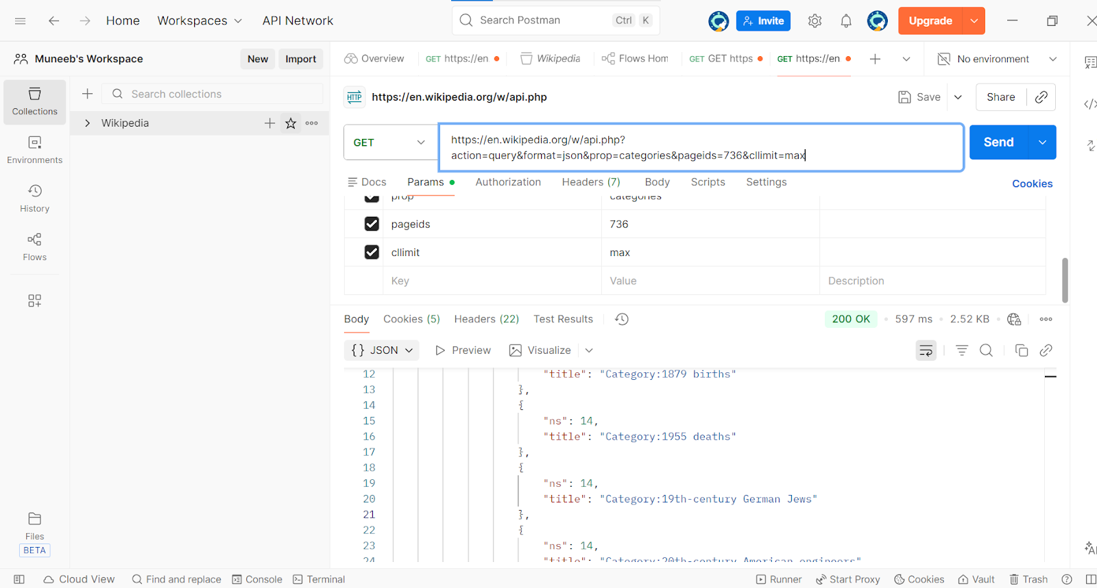

Test Case ID | TC_API_11
Test Case Title | Verify Wikipedia API retrieves page images
API Type | GET
API End Point | /w/api.php
Request Parameters | action=query  format=json  prop=images  pageids=736  imlimit=max
Full Request URL | https://en.wikipedia.org/w/api.php?action=query&format=json&prop=images&pageids=736&imlimit=max
Expected Result | "Albert Einstein".  Response includes an array of images present on the page,
Actual Result | "title": "Albert Einstein",  "images": [  {"ns":6,"title":"File:Albert Einstein Head cleaned.jpg"},  {"ns":6,"title":"File:Albert Einstein as a child.jpg"},  {"ns":6,"title":"File:Albert Einstein at the ag}
Status | Pass
Remarks | This test case validates that all images on a page are retrieved without using search.  Useful for testing media extraction from Wikipedia pages.

Screenshot:
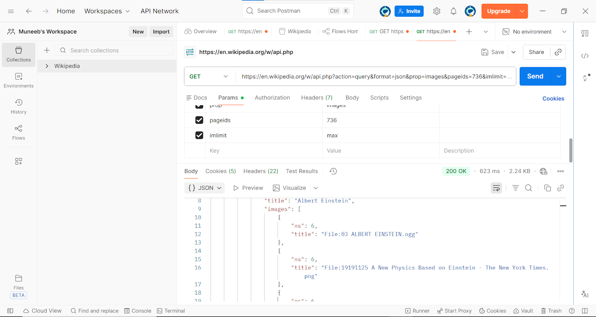

⋆˙⟡ T H A N K Y O U ⟡˙⋆

